Paul Kafka
3/22/12
Homework 6

Design the Timed FSM specified in Exercise 11.14 of our textbook. Include an automated functional simulation (Type III testbench) for your circuit. Be sure to turn in results that show correct operation of your circuit.
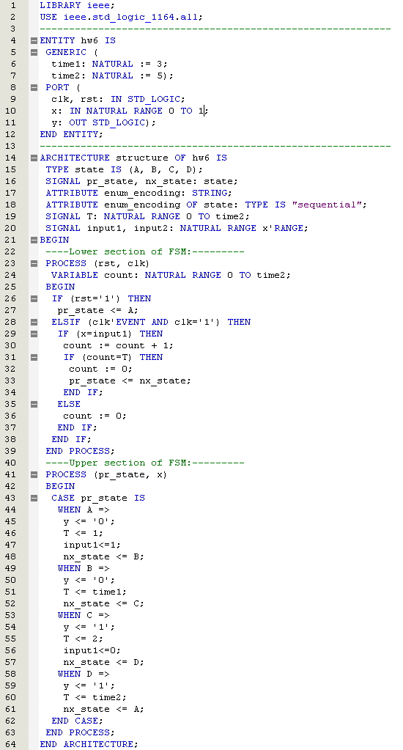
FSM
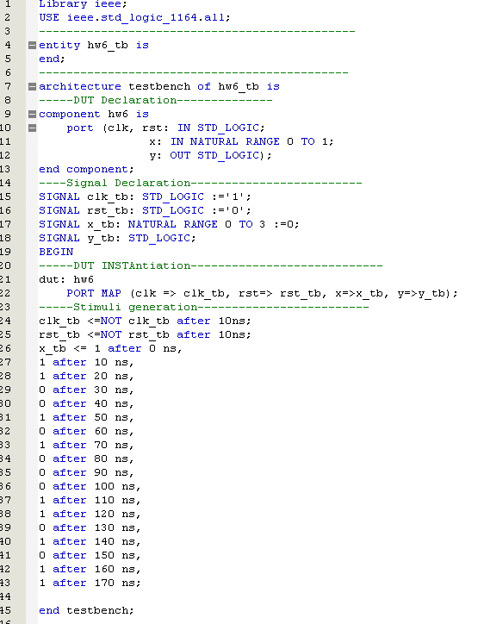
FSM TESTBENCH
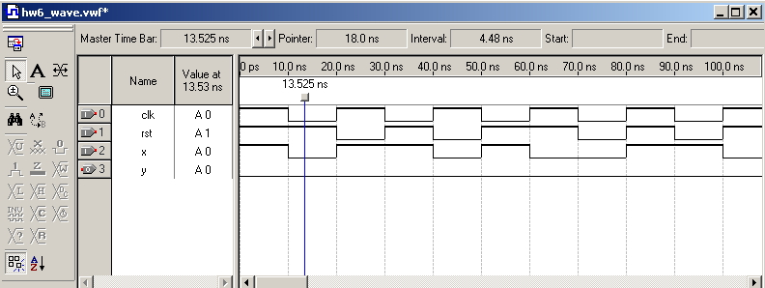
Functional Wave Simulation

